Cranbourne East Primary School

2 Bowyer Ave. Cranbourne East 3977
Ph. 5990 0400

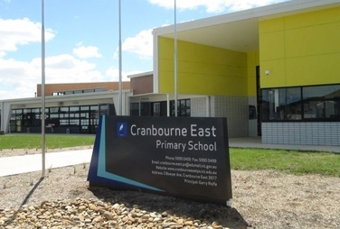

Foundation Year
(Year Prep) Information
Booklet 2020

Contents

Welcome to school p3
School contacts p4
Term dates for 2020
& special school times for Foundation students p5
Getting ready for school p6
Before your child begins school p7
Areas for school readiness p8
Beginning school p9
Co-teaching at CEPS p10
Your Child’s First day p14
School Norms p15
Early Years Evaluation & School Entry Assessment p16
The first few weeks p17
When your child starts school p18
School uniform p19
Some helpful information p20
Some things you can do at home to help p21
What else can you do to help? p22
Effective Parent/Teacher/School Communication p23
Parent helpers p24

Welcome to Our School

This booklet provides information that will assist in making your child’s transition into school a smooth process. We look forward to building the home-school partnership for the duration of your child’s primary school education.

We aim for the partnership to be a happy and constructive process, which will see your child develop and achieve their potential with the support of dynamic, caring, creative and talented teachers.

You have been there from day one. You are your child’s first teacher and no-one will know your child as well as you. We are here to continue to assist in the development of your child’s skills and social competencies and enhance life skills that will be the basis of all future learning. We will instil a love of learning which embraces a child’s natural curiosity and the questions they ask about life and equip them with skills of Literacy, Numeracy and Inquiry Based Learning.

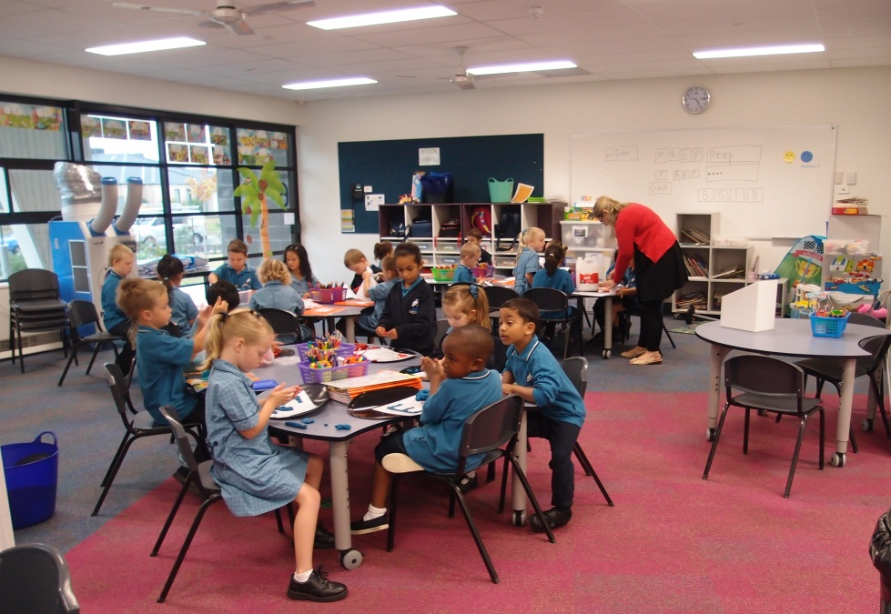

School Contacts
Street Address: Cranbourne East Primary School No: 5518
2 Bowyer Avenue
Cranbourne East 3977

Postal Address: 2 Bowyer Avenue
Cranbourne East 3977

Phone: 03 5990 0400

Fax: 03 5990 0499

Website: www.cranbourneeastps.vic.edu.au

Email: cranbourne.east.ps@edumail.vic.gov.au

Melway Ref: 134 E4

Principal: Garry Rolfe

Assistant Principals Michelle Wrigley
Jenni Kelly
Chanel Herring
Mitch Welsh

Welfare Office Vicki Turnbull

Business Manager Faye Hanks

School Administration Ailsa Cooke
Tania Hiroa-Maiava
Amanda Milsum
Jane Faulkner
Beverly De Souza
Jessica Rhodes
Zora Sterjovski

First Aid Officer Natalie Okey

School Council President Roz Coles
Term and Other Dates for 2020
Term 1: Tuesday 28th January to Friday, 27th March
Term 2: Tuesday 14th April to Friday 26th June
Term 3: Monday 13th July to Friday 18th September
Term 4: Monday 5th October to Friday 18th December

Timetable for Foundation Students

Thursday 30th January | All Foundation students attend, finishing at 12:00pm
Friday 31st January | All Foundation students attend, finishing at 12:00pm
Monday 3rd February | All Foundation students attend, full day 9am-3:15pm
Tuesday 4th February | All Foundation students attend, full day 9am-3:15pm
Wednesday 5th February | Foundation students do not attend school.  School Entry Assessment by appointment.
Thursday 6th February | All Foundation students attend, full day 9am-3:15pm
Friday 7th February | All Foundation students attend, full day 9am-3:15pm
Monday 10th February | All Foundation students attend, full day 9am-3:15pm
Tuesday 11th February | All Foundation students attend, full day 9am-3:15pm
Wednesday 12th February | Foundation students do not attend school.  School Entry Assessment by appointment.
Thursday 13th February | All Foundation students attend, full day 9am-3:15pm
Friday 14th February | All Foundation students attend, full day 9am-3:15pm
Monday 17th February | All Foundation students attend, full day 9am-3:15pm
Tuesday 18th February | All Foundation students attend, full day 9am-3:15pm
Wednesday 19th February | Foundation students do not attend school.  School Entry Assessment by appointment.
Thursday 20th February | All Foundation students attend, full day 9am-3:15pm
Friday 21st February | All Foundation students attend, full day 9am-3:15pm
Monday 24th February | All Foundation students attend, full day 9am-3:15pm
Tuesday 25th February | All Foundation students attend, full day 9am-3:15pm
Wednesday 26th February | Foundation students do not attend school.  School Entry Assessment by appointment.
Thursday 27th February | All Foundation students attend, full day 9am-3:15pm
Friday 28th February | All Foundation students attend, full day 9am-3:15pm
Monday 2nd March | Preps start full time school

Getting Ready For School

It will be helpful if you can teach your child to do these things for themselves before they come to school:

- Attend to their own toileting needs including washing their hands after using the toilets. Be sure your boy understands how to use a urinal.

- Recognise their own name, particularly on their clothing.

- Manage a lunch box, and know which food is for snack and what to eat at lunch.

- Eat their lunch and in the correct sequence.

- Know and be able to say clearly their full name.

- Understand and carry out an instruction.

- Sit quietly for a short time.

- Remember to use their manners; ‘Please’ and ‘Thank You’ goes a long way!

- Have some experience of playground equipment, such as climbing frames.

- Speak quietly indoors.

- Pack and do up their case or bag.

- Wipe up spilled water, paste etc.

- Look after his/her belongings.

- Dress themselves. Including taking their jumper off.

- Tidy up after they have used something.

- Use a tissue to blow their nose.
Before Your Child Begins School

Before your child begins school talk to him/her and discuss what they can expect. Talk about their concerns and reassure them that the teachers are here to look after them and assist them.

Go for a walk around the school. Discuss the play areas and where the toilets are. Talk about making new friends. Talk about eating and play times. Tell them there will be teachers they can go to for assistance in the playground if they are unsure about anything. The teachers wear bright orange vests and can be easily seen in the playgrounds.

When you drop your child off leave quickly without any fuss. If your child is upset reassure them you will return to pick them up after school and then leave them in the hands of their teacher. Once a parent leaves, an upset child generally settles quite quickly. Remember teachers are professionals, experienced in working with children and know how to care for a distressed child.

At the end of the day talk to your child about their day and ask them ‘What was the best part of the day?’ ‘What did you learn today?’

Areas For School Readiness

- Your child needs to be able to relate to adults outside the family.
Your child should be able to:
  - listen to the teacher.
  - follow the directions of the teacher.
  - make known to the teachers what he/she needs.

- The child needs to separate easily from the parents.

- Confidence: The child who sees themselves as generally being successful will be more prepared to try the new challenges offered at school. Praise works wonders!

- Independence: School provides a wide range of engaging learning activities for your child. Those children who do not need direction in occupying themselves can attempt much more, and consequently will learn much more. Don’t criticise failure. Remember, your child is doing their best.

- Persistence: The child who never sees a task through to its completion is going to be at a disadvantage at school, where new learning tasks are dependent upon the completion of previous ones. Encourage your child to keep trying and finish things they’ve started. This enables your child to see the value of persistence.

- All Staff at Cranbourne East Primary School are here to nurture assist and guide your child to achieve their potential along the learning journey.

Beginning School

The beginning of your child’s school life is both exciting and challenging! It is one of the moments you are asked to put your trust in others to educate and care for your child. It is the beginning of your child’s formal education but it carries on from the sound grounding that your family has provided.
The initial year of school will set the pattern for the years ahead. Positive attitudes to school are established and our commitment to making your child feel secure and a part of the school community is very important.
Your child’s previous experiences and skills are taken into account when we set up personalised learning programs. Early in the year we will ask you to meet the class teacher and participate in a School Entry Assessment Interview where you can share information about your child’s needs.

Families are keen for their children to succeed and be happy at school. Families who actively support their children during transition, and who build positive relationships with school staff, are likely to continue this positive engagement with school …
Transition – A Positive Start to School, DET

So we begin the journey and ask that if you have any questions please contact your child’s teacher.
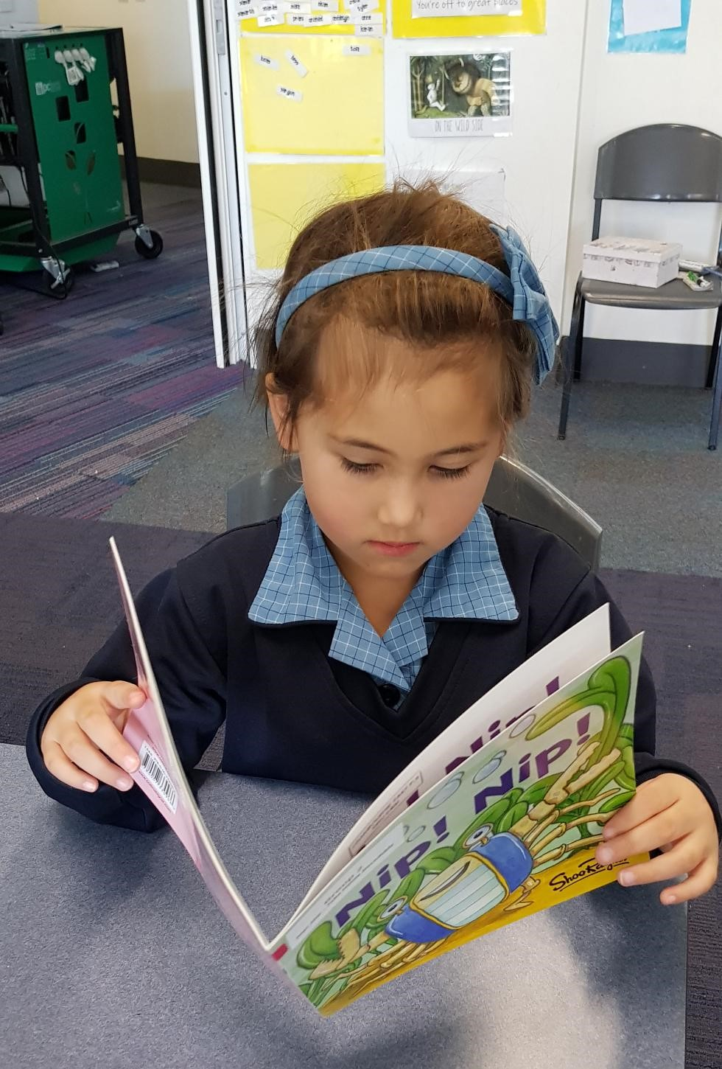
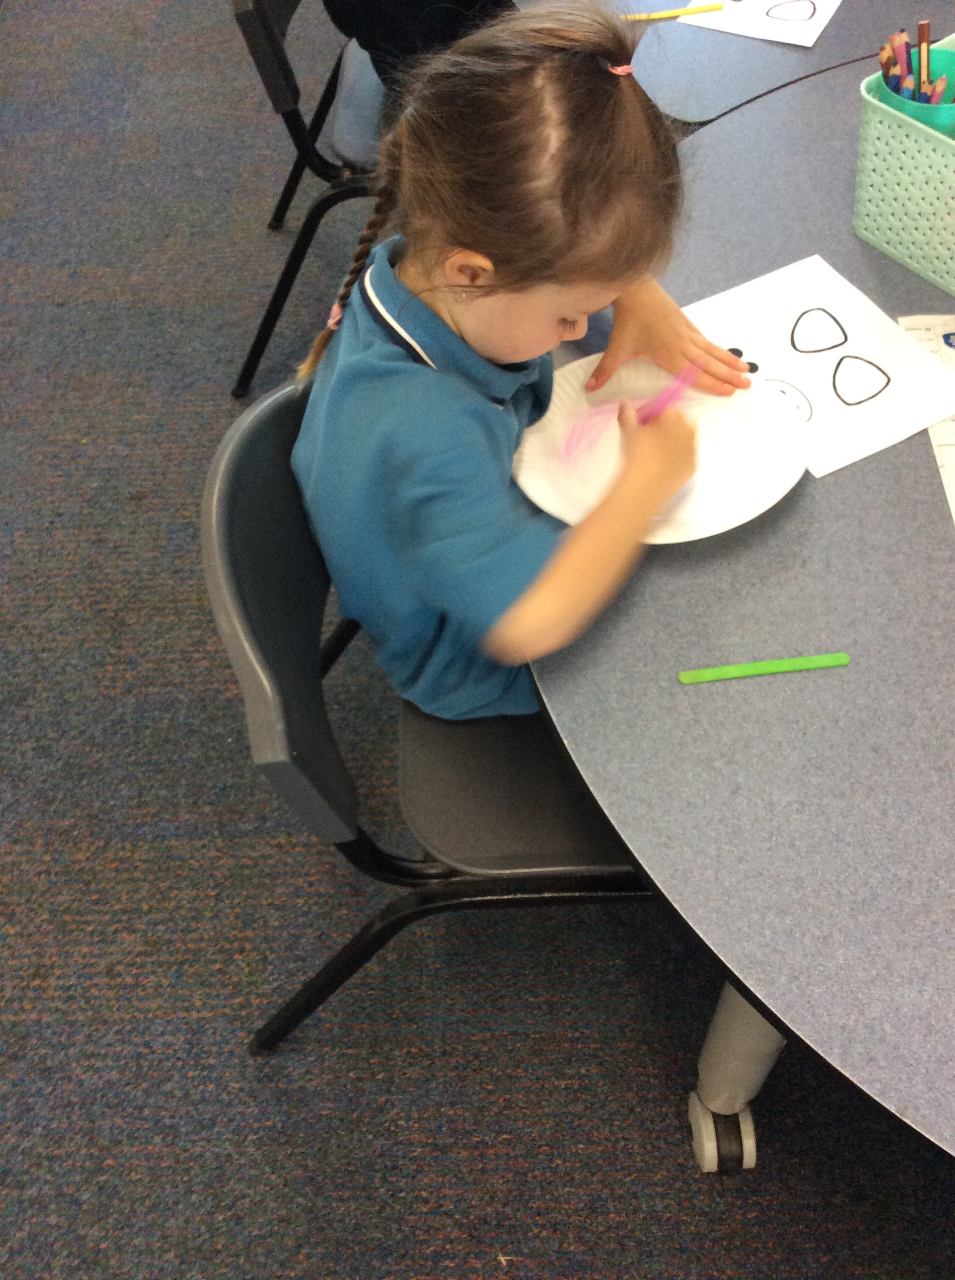

Co-Teaching at
Cranbourne East Primary School

At Cranbourne East Primary School we have adopted a Co-Teaching program which supports current and best practice in education involving a group of teachers working with a group of students. In our case the groups are in home groups and occupy various spaces around the building and classrooms. It is important to note that all areas of the buildings are teaching and learning spaces.
The building is purpose built to allow flexible teaching and learning to take place.
The openness of the areas support different styles of learning and group work and allows teachers to be part of a team who work with a group of children.

What is Co–Teaching?
Put simply, Co-Teaching is a group of two or more teachers working with a group of children. The teachers share all aspects of the teaching and learning, including planning, teaching, assessing and looking after the well-being of all the students. They are a team.

Will my child still have a classroom teacher?
The children are set up in ‘home groups’. Each home group is allocated a teacher to cater for administration purposes, for report writing and parent teacher interviews. Instead of class teacher, the term ‘home group’ teacher has been adopted.

Does my child have an allocated classroom?
We use the term ‘Learning Space’. Each Home Group has an allocated Learning Space. This again is for administrative purposes.

Which teacher does my child work with?
Your child works with a team of teachers. Your child’s home group is part of a bigger team.
All the teachers in the team work with all the children. For example, each Foundation team currently has two or three teachers and two or three home groups who work together. All teachers in the group work with different children at various parts of the day. The children are grouped according to the activity they are doing and the skills and interests of the children. Teachers will be responsible for teaching explicit skills to the various groups throughout the day. Decisions about what is to be taught are guided by the needs of the children as outlined by an intensive assessment program and by the Victorian Curriculum, which provides a comprehensive set of content descriptions and associated achievement standards which schools use to plan student learning programs, assess student progress and report to parents.

How does the teacher know how my child is progressing?
All teachers in the group will work together in monitoring student progress. Your child’s home group teacher will keep a record of how your child is progressing and will also be responsible for implementing the required formal assessments as outlined on our Assessment Schedule. If your child is working with another teacher, that teacher will take notes and make observations and will report findings back to the home group teacher. This is done either verbally or will be recorded in documents that will be stored electronically.

Why is my child’s learning space ‘empty’?
You may have noticed that some learning spaces are ‘empty’. This is because the learning space is part of what we call a Learning Neighbourhood. The Learning Neighbourhood consists of up to four Learning Spaces which ‘break out’ onto a larger space. This larger space is used for group work, area meetings, computer stations, and other learning activities. It is a space where children can complete activities under teacher supervision.
The ‘empty’ learning spaces are where the group meets as a whole in the morning to take the roll and greet the students and then move on to the learning rotations, take part in a whole group activity, or to use as a flexible learning space.
All furniture is accessed by all students in the area. Research indicates that students need a variety of space, furniture and tools to help them learn to cater for individual learning styles. You might find children in ‘bean bags’ using an iPod or on the floor completing an activity. Depending on the activity children are given a choice.
Are the learning spaces noisy and is my child properly supervised?
The learning spaces are orderly and work at various levels of sound according to the activity. The teachers set very clear boundaries and supervise at all times by ‘roaming’ through the ‘neighbourhood’ assisting where necessary.
There will be a combination of explicit teaching, group work, computer work, use of an interactive television or individual work.

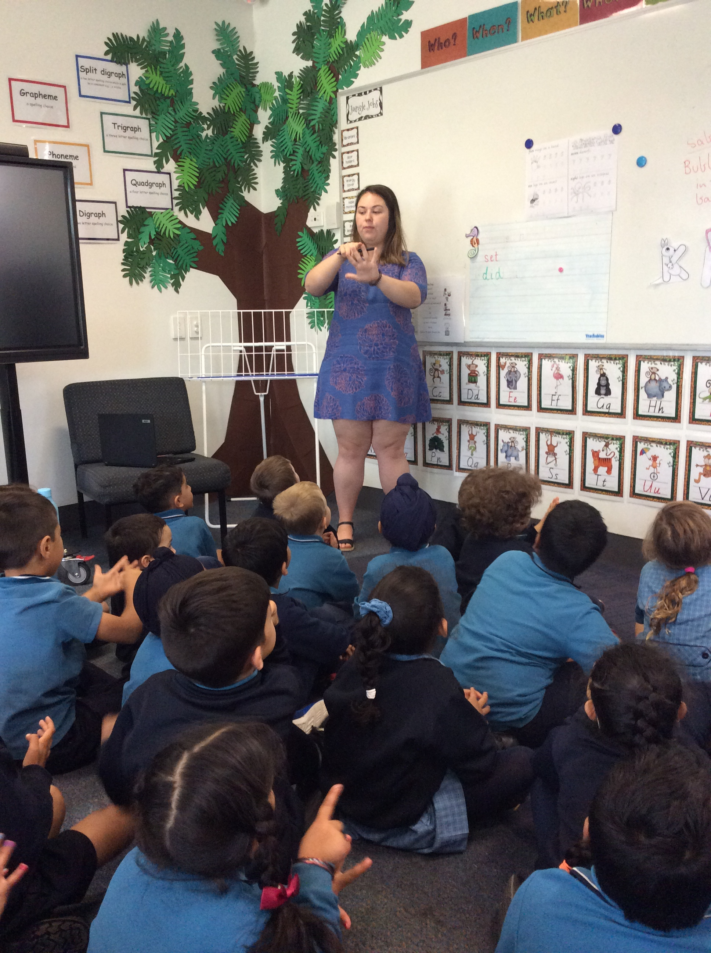

School Norms
These are expectations we have for all students at Cranbourne East Primary School.
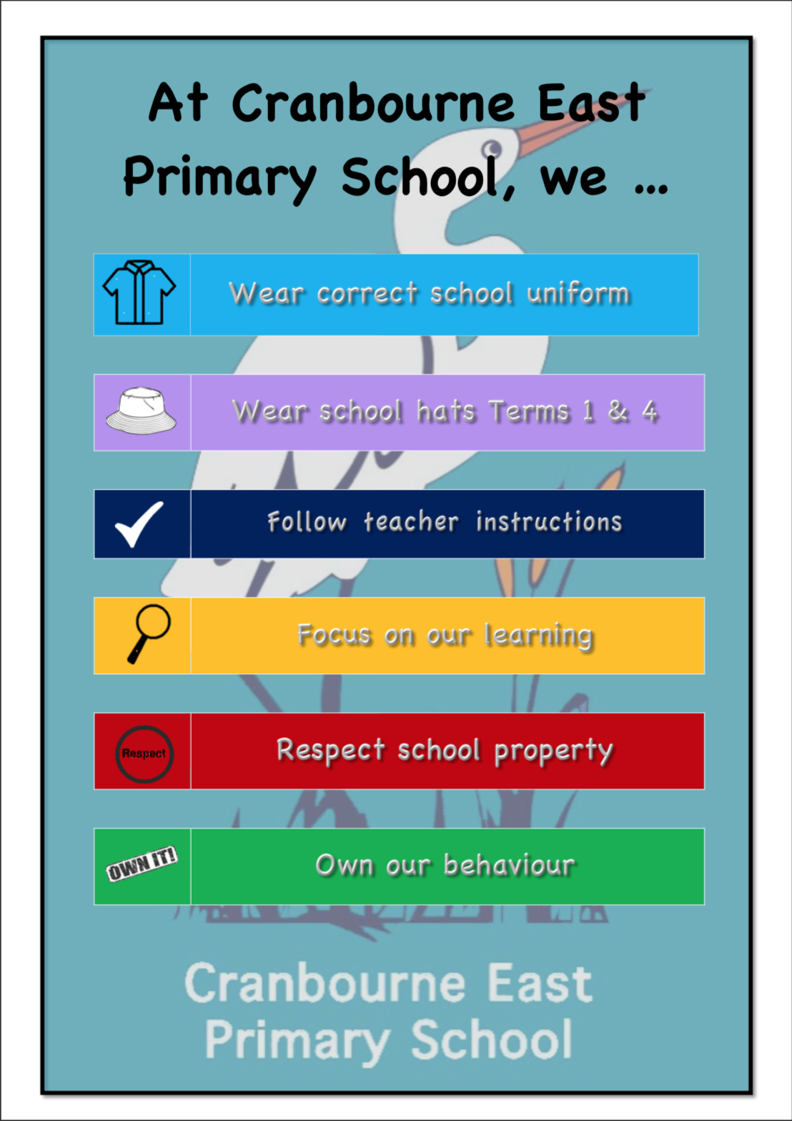

Your Child’s First Day

The first day will include activities to introduce the Foundation children to their new school.
For the first two days, Thursday 30th January and Friday 31st January, Foundation students will finish school at the earlier time of 12:00pm.

Week Beginning Monday 3rd of February, 2020
From Monday 3rd of February all Foundation children will be attending normal school hours 9:00am-3:15pm. Foundation children will attend school on MONDAY, TUESDAY, THURSDAY and FRIDAY. The children will not attend on WEDNESDAYS for the first four weeks of school.

From Monday 2nd March, all Foundation children will be attending school five days per week.

Procedure for the First Day

At the Information Evening on Monday 2nd December 2019 you will find out your child’s home group, learning space and the name of your child’s teacher.
On the first day, arrive at school well before 9:00am with plenty of time to spare. Go to your child’s learning space using the external door where your child’s teacher will greet you. From here follow the direction of the teacher.

- There will be a name tag for your child, a locker tub and provision for their bag.
- Please say good bye to your child and then leave your child with the teacher. The children settle quite quickly and will begin to interact with the other children.
- It is essential that all your child’s belongings are clearly named. All items of clothing, their lunch box, drink bottle, school bag, and especially their hat!
- Remember hats must be worn as part of our SunSmart policy during the first term and fourth term.
- Make sure your child knows the procedure for the end of the day and that you will collect them from their learning space.
- Chat to them about their day and check for any notices or reminders that may be in their bag.

The Two Foundation Year Assessments

Early Years Evaluation (EYE)
Students entering the Foundation Year in 2020 will participate in the Early Years Evaluation assessment during Term 4, 2019. The EYE is a tool used across all of the Cranbourne Network of Primary Schools. The EYE provides a leading assessment of children’s development as they enter school. It also provides accurate data that helps teachers teach to the individual student point of learning, increase learning time, and monitor each child’s progress. The evaluation also informs parents about their child’s progress. All assessment data is managed in accordance with the Department of Education and Training and Privacy legislation. Information is to be provided to parents prior to the commencement of the EYE assessment.

School Entry Assessment

The ‘School Entry Assessment’ is mandatory as set by the Department of Education and Training and provides essential knowledge for the teacher to use when designing a personalised learning program for your child. You will be given an appointment time on one of the Wednesdays in the first five weeks of school so that the teachers can administer this assessment.

The following assessments will be undertaken:
- The English On-line Interview
(Includes letter/sound identification, concepts about print, observation of pre-reading skills etc).
- Early Years Numeracy

The assessments take approximately 30 minutes. Your child’s teacher will conduct the assessments one-on-one with your child, followed by a short interview with parents.
The First Few Weeks

Your child’s first few weeks will be busy and will see him/her adapt and adjust to school life. Some points to remember:

- In addition to regular yard duty staff, the Foundation teachers will be out in the playground constantly for the first week during recess and lunch. This is to ensure students feel comfortable and that they know there is a familiar adult nearby. Teachers on yard duty are assigned to cover all play areas and wear a bright orange vest so they are easily visible to the students.

- Your child will eat their food inside. Students will have a fruit break at 10:00am, a snack at 10:45am and lunch at 1:15pm.

- Your child will need to wear an approved school hat during Terms 1 and 4. The only approved hat is the Cranbourne East Primary School hat available from Primary School Wear (PSW).

- Take home books will be sent home in Term 1. Letters and words for revision at home will also be included with take home books throughout the year.

- Notices will be sent home on a Friday of each week. Look out for these in your child’s Reader Bag.

- If you have any questions at any time please don’t hesitate to contact your child’s teacher.

When Your Child Starts School

To ensure that your child can achieve their maximum potential please ensure your child has sufficient sleep, arrives at school on time and is seated, ready for learning by 9:00am.

Regular attendance helps:

- Good school work
- Good social adjustment
- Development of independence

Absence can easily disadvantage a child’s progress. The first year at school like all years is most important and unnecessary absenteeism can inhibit student progress.

Home is a good place for a sick child. It is unfair to the child, other children and teachers to send a child to school who is obviously ill. One day of lost learning is one day that can not be recovered.

If your child has any difficulty with any aspect of school please speak to the class teacher early in the year or note it on the emergency information form.

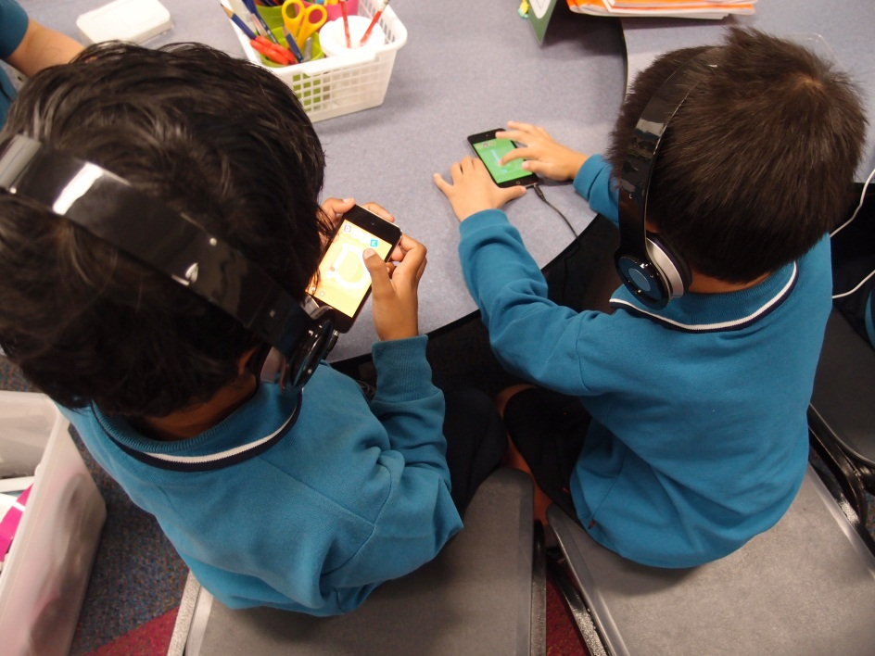
School Uniform

COMPULSORY SCHOOL UNIFORM

School Council has ratified the following as compulsory school uniform.

Unisex
- School Windcheater Navy (V neck)
- Trousers/Pants Navy (includes tracksuit pants)
- Polo shirts Teal (short and long sleeved)
- Broad Brim/Bucket Hat Navy
- Shorts Navy
- Socks White or Navy
- Shoes Safe, sensible and appropriate.
Black leather school shoes or runners.
No open-toe shoes or sandals.
.
SUMMER CLOTHING
Dress Teal and Navy Check
Skort Navy

WINTER CLOTHING
Tights Navy
Skivvy Navy
Tunic/Skirt Navy
Raincoat Navy

SCHOOL UNIFORM IS AVAILABLE FROM
PSW
Unit 2, 10-12 South Link (South Gippsland Highway)
DANDENONG SOUTH, VIC, 3175
Ph: 03 9768 0343
Website: http://www.psw.com.au/
Some Helpful Information

- Absence: For optimum learning your child is expected to be at school every day on time unless they are ill. A note is to be provided explaining your child’s absence on the day they return to school or a phone call to the Office on the day will be appreciated.

- Late Arrivals: All children who arrive late must be signed in by the parent at the Administration Office.

- Early Leavers: All children who need to be picked up early need to be collected at the Office and signed out.

- Prescription Medication: If a child requires prescription medication throughout the day it must be labelled with the child’s name, class and dosage. There is a form at the Administration Office which must be completed, including the medication and instructions.

- The canteen is open Monday to Friday. Lunch orders are ordered online.

- The canteen will be open during recess and lunch for the purchase of drinks and snacks only.

- Spare Clothes: It is recommended that children in Foundation have a spare set of clothing in their school bag. If a student has soiled their clothing and does not have spares, the parent/guardian will be contacted.

- Online assemblies occur each week and a whole school assembly is held in the gym at the end of each term. More information on assemblies can be found in the newsletters and on the school website.

- School Banking: Student banking deposits are processed every Friday.

- Lost Property: All belongings should be clearly labelled for easy return. Lost property is located on the clothes rack near Room 8 via the external school entrance.

- Toys and Valuables: Please note toys and valuables are not to be brought to school. The school is not responsible for these items coming into the school.
Some Things You Can Do at
Home to Help

A positive attitude to school begins at home. Your child’s success at school depends on your beliefs about school and how you approach their first day. Talk to your child about what to expect and make sure that they have enough knowledge about school to make their transition smooth and worry free.

There are some things you can do at home to help your child learn. All children are curious and ask questions! They are born with these skills! Our job as parents and educators is to enhance this natural curiosity and ensure that children have the opportunities to learn and the skills to search for answers.

- Read to and with your child on a daily basis, even during holidays. This is an important experience as it places value on learning to read and early literacy provides many opportunities for rehearsing and listening to the pronunciation and structure of words.

- Participate in activities with your child that promote a chance to experience a variety of different life experiences. Go to the Zoo, the beach, take a drive to the airport, the local library or take part in the many activities your local council provides. Cook with your child. This includes buying the necessary ingredients from the supermarket for what you are going to cook. Play family games and allow your child to develop skills of independence by giving them some responsibility, for example feeding the pets.

- Have continual discussions with your child. The skill of being able to articulate thoughts and ideas has a huge impact on all aspects of language development including, speech, hearing, writing and reading. They are practicing skills as they are engaged in a conversation.

- Sing songs with your child. It is fun and again, reinforces language conventions. Allow your child many opportunities to explore their own environment. Your backyard is a ‘wonderland’ for early exploration.

- Encourage your child to take care of and be responsible for their belongings. This will help them enormously before they start school.

- Count different things with your child.

- Provide materials that your child can sort and put into categories.

- Above all reassure your child when they are feeling anxious in a calm and soothing manner.

- Don’t force your child to do anything as this can create anxiety and stress.

Enjoy this special time with your child. The foundations laid during their first year at school will be the basis for success for the rest of your child’s school life.

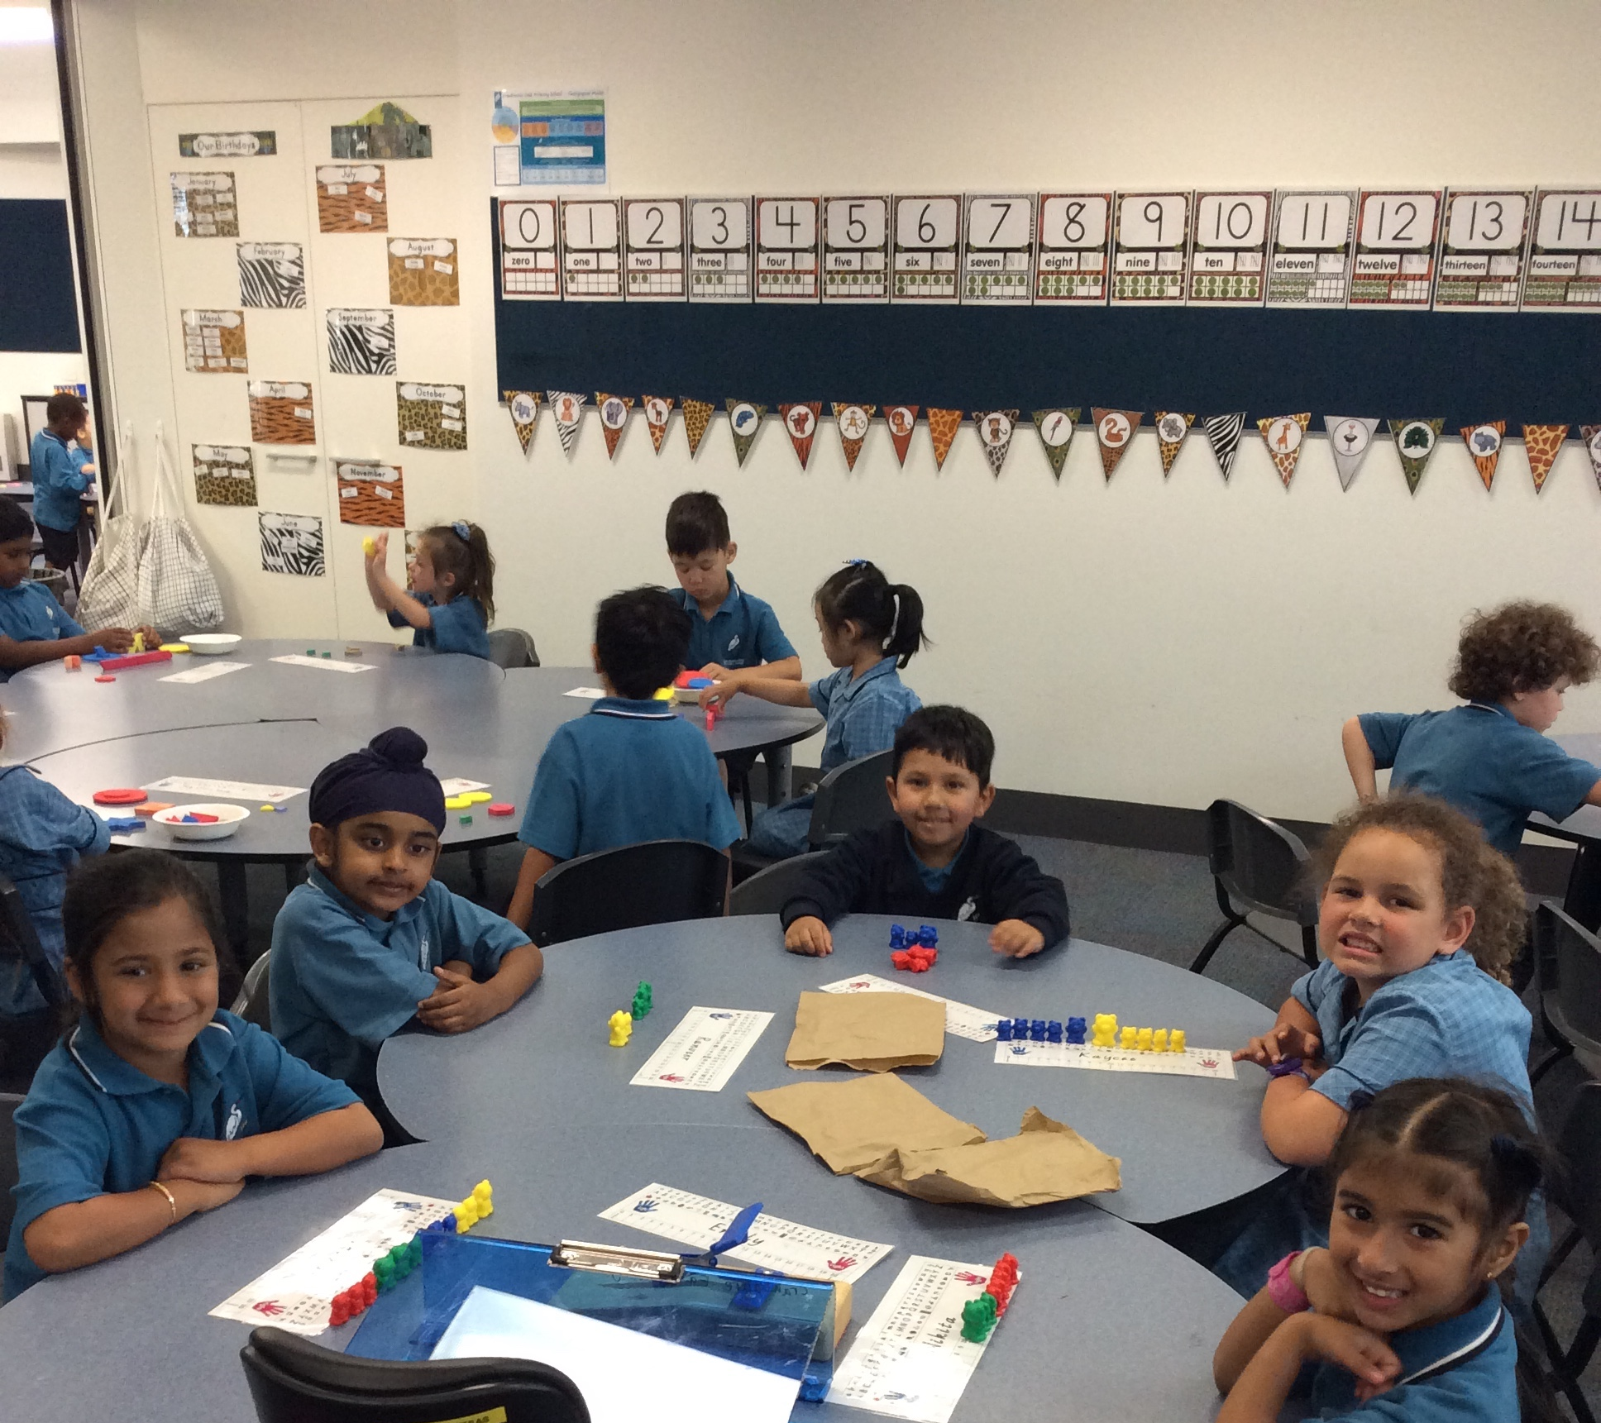

What Else Can You Do to Help?

- Talk to your child about school, where they will meet new friends, play games, sing and make things.
- Admire and display the work your child does.
- If possible, allow your child to stay with relatives or friends for short periods so that your child will accept being away from you.
- Select suitable stories, radio and television programs.
- Be very patient and understanding when your child comes home tired.
- See that your child has sufficient sleep.
- Ensure that your child has a hearty breakfast before school.
- Show by your words and actions that school is a happy place.
- Please make sure your child knows how to cross the road safely, stressing the need to use the school crossing.
- Make sure your child understands to wait for you at an arranged place.
- Set aside a quiet time each night (need only be a few minutes) where you make yourself entirely available to your child, to talk or listen, or tell a story.
- Make sure the following items are not brought to school; expensive or easily broken toys, jewellery, glass bottles or containers. Dangerous toys such as guns, swords or knives are not permitted.
- Ensure your child is at school on time each day.
- Ensure your child attends school each day unless ill.

Above all talk with your child at every available opportunity. Share songs, rhymes, poems and stories. Encourage your child to speak often and clearly. This is of great importance and will enhance your child’s language development.

What to do when you ask your child
‘What did you do at school today?’ and they reply ‘NOTHING!’

When asking your child how their day at school was, it is a good idea to ask specific questions about aspects of their day in order to get a more detailed response e.g. What was the best part of your day?

Effective Parent/Teacher/School Communication

Communication between teacher and parent is a vital part of your child’s development. It is therefore advisable to discuss any concerns or relevant information about your child with your child’s teacher. Times to do this vary.

Formal student led conferences are arranged mid-year and again at the end of the year. Informal discussions are welcome although not during actual class time.

By mutual agreement, before school or after school are appropriate times to ensure the learning programs are not interrupted. Should you wish a more formal arrangement to occur please contact the school for an appointment.

Appointments to see the Principal or Assistant Principals may also be made if the need arises. Teachers also welcome the discussion of programs with parents and while this is usually done formally at the beginning of the year, you may discuss programs with teachers, providing an appointment has been made.

Parent Helpers
(Working with Children’s Check)

Parent helpers are greatly valued and appreciated by the teachers and the children. Parents can assist in a variety of ways – classrooms, excursions, assisting with reading groups, publishing books, etc.

Any person who volunteers to work within the school is required to present a satisfactory ‘Working with Children Check’ and be approved by School Council.
If you wish to become a helper please obtain a Working with Children’s Check. Forms can be obtained from your local Australia Post Office or you can apply online by going to http://www.workingwithchildren.vic.gov.au . There is no cost for volunteers to obtain this pass.

A Classroom Helpers program will also be offered to parents early in the school year. This course is designed to support the work of parents who assist in classrooms and is linked to the classroom literacy and numeracy program.

Child Safety
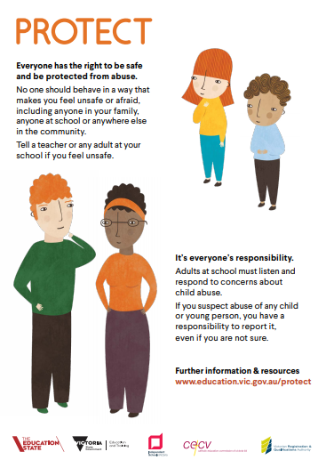
Victorian Government Initiative

Child Safety Online
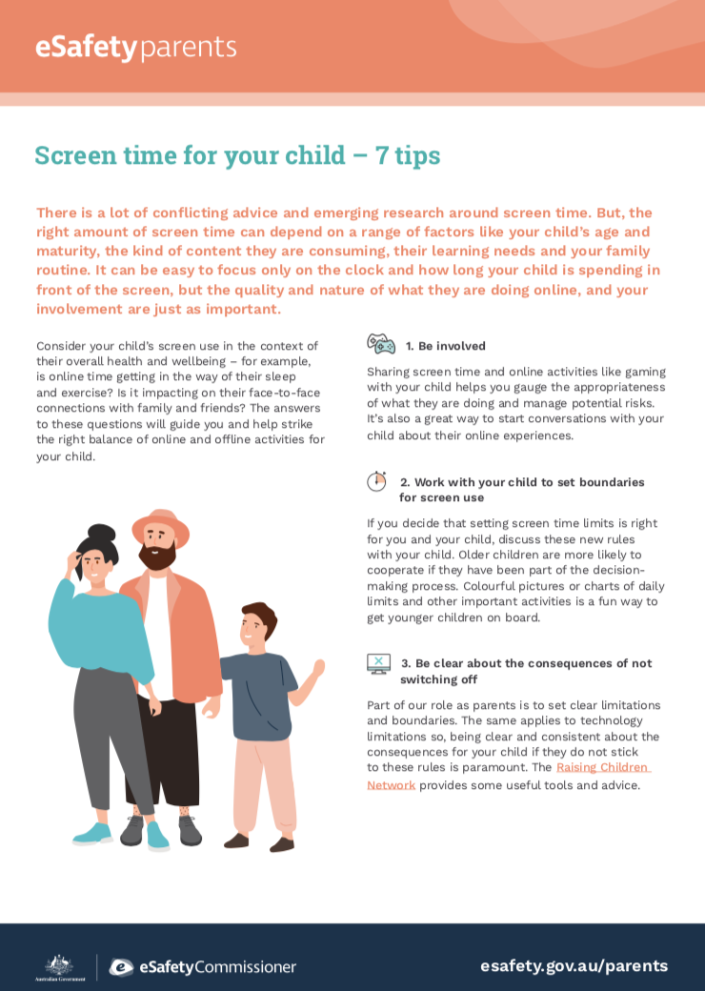
Your child’s safety online is important. Here are some tips. For more information go to esafety.gov.au/parents

